AJ - PRACOVNÍ LIST RODINA - 7. ROČNÍK
Doplněné poslat na e-mail ke kontrole do středy 1.4.!
Jméno:
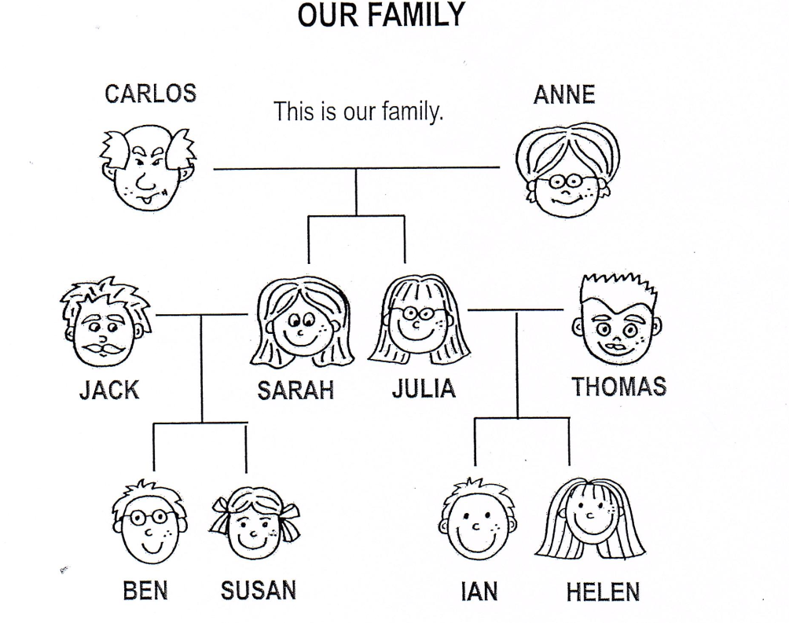
Hi! I am Susan and this is my family: (Doplň věty slovy z nabídky)
BEN is my
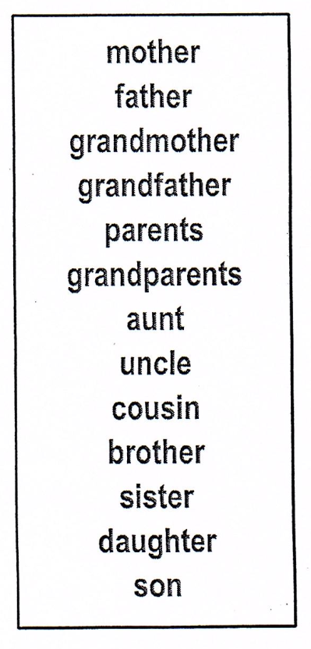
IAN is my
HELEN is my
JACK AND SARAH are my
JACK is my
SARAH is my
JULIA is my
THOMAS is my
CARLOS AND ANN are my
CARLOS is my
ANNE is my

